APhA Academy of Student Pharmacists
2023-2024 Regional Officer Elections

REGIONAL OFFICER POSITION DESCRIPTIONS

APhA-ASP shall be structured with eight regions around the United States. Each region shall elect the following offices to represent their region: APhA-ASP Regional Delegate and APhA-ASP Midyear Regional Meeting Coordinator. The terms of APhA-ASP regional offices expire at the conclusion of the Midyear Regional Meeting following their election.

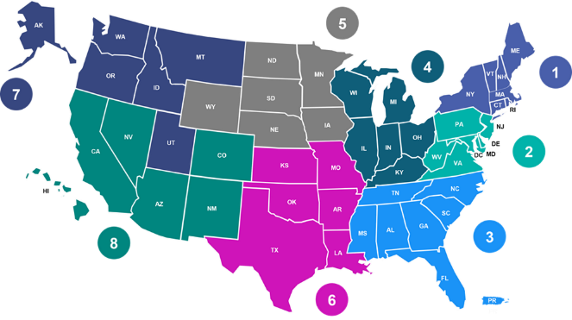

Serving as an American Pharmacists Association Academy of Student Pharmacists (APhA-ASP) Regional Officer is rewarding and satisfying, both professionally and personally. Students who choose to serve their profession in this capacity have the personal satisfaction of knowing that they have been elected to represent student pharmacists in a national and international professional society. At times, serving as an APhA-ASP Regional Officer is a demanding job that requires sacrifice, but the position is meant to complement, not compete with the leader’s education.

ELIGIBILITY

- Any APhA-ASP member enrolled as a full-time student in a Doctor of Pharmacy degree program is eligible to seek nomination for an elected regional office. All APhA-ASP elected regional officers are to remain in their first professional degree program during their term(s) of office.
- Candidates for office must have a satisfactory record of academic performance (minimum 2.5 GPA on a 4.0 scale) and understand that the responsibility of being elected as an APhA-ASP Regional Officer must not negatively affect the candidate’s current academic standing.
- Candidates must be of sound professional, moral, and ethical judgment and must have the full support of the dean, experiential coordinator, and chapter advisor(s) at their school or college of pharmacy.
- Candidates must be aware of the responsibilities, meetings, and requirements of the position they seek. If after being elected, a candidate finds that they are unable to fulfill the duties of the position, the candidate understands that APhA has the authority to replace them with a qualified student pharmacist.
- Candidates, upon the discretion of APhA, may be required to resign from any local, regional, national, or international positions held in APhA-ASP, or other pharmacy and non-pharmacy associations.
- An official Regional Officer Application must be submitted to APhA Headquarters by the date specified on the application. Each section must be fully completed, and the application must be signed by the chapter advisor(s) and experiential coordinator of the applicant’s school or college of pharmacy. Portions of the application will be made publicly available on APhA-ASP’s website.

- Candidates must have all campaign materials approved by APhA Student Development Staff. Failure to comply may result in disqualification as a candidate.
- Candidates must understand and adhere to all sections of the APhA-ASP House of Delegates Rules of Procedure and APhA-ASP CAPSULE.
- Candidates must be aware and able to attend required meetings:
Event | Event Date | Encouraged to Participate | Required to Participate
APhA-ASP Regional Officer Orientation  (conducted via Zoom) | November 20  (8:30 pm -10:00 pm ET) | — | Yes
APhA-ASP Regional Officer Meeting | January 12-14 | — | Yes
APhA2024 Annual Meeting | March 22-25 | — | Yes
APhA-ASP Summer Leadership Institute | July (days TBD) | Yes | —
APhA-ASP Midyear Regional Meeting | October / November (days TBD) | — | Yes

APhA-ASP REGIONAL DELEGATE

APhA-ASP Regional Delegates lead the policy and advocacy activities of the region. Responsibilities include, but are not limited to:

- Serve as one of the eight members of the APhA-ASP Resolutions Committee. The committee is Chaired by the Speaker of the APhA-ASP House of Delegates. This committee chooses the most important ideas from those passed during the APhA-ASP Midyear Regional Meetings and formulates proposed resolutions and background statements. These statements are presented to the APhA-ASP House of Delegates at the APhA Annual Meeting & Exposition.
- Serve as one of the 28 APhA-ASP Delegates to the APhA House of Delegates at the APhA Annual Meeting & Exposition. Regional Delegates are required to attend and participate in all APhA House of Delegates interim meetings called by the APhA Speaker of the House, all APhA-ASP caucuses.
- Assist with additional APhA-ASP events as assigned by APhA Staff at the APhA Annual Meeting & Exposition.
- Collaborate with the APhA-ASP Policy Standing Committee to promote advocacy initiatives and engage student pharmacists in the regional policy process activities.
- Work with the MRM Coordinator to maintain good communication within the Region.
- Serve as a student voting member in the APhA Board of Trustees election process.
- Works closely with the MRM Coordinator and APhA Staff to assist in Midyear Regional Meeting planning.
- Moderate APhA-ASP Policy Proposal Forum conducted during the Midyear Regional Meeting.

APhA-ASP MIDYEAR REGIONAL MEETING COORDINATOR

A Midyear Regional Meeting Coordinator is elected at the each of the eight APhA-ASP MRM and has specific duties as a regional representative for APhA-ASP, including but not limited to:

- Assists APhA Staff in ensuring that the APhA-ASP MRM is a well-planned and smoothly running APhA-ASP activity.
- Works to help promote the MRM in his or her region by notifying schools and colleges of pharmacy in the region. Contacts the APhA-ASP MRM Ambassador in the region to request their assistance and support in promoting MRM to their chapters.
- Serves as the MRM moderator and coordinates the logistics during the meeting.
- Works with the Regional Delegate maintain good communication within the Region.
- Promote MRM supporter opportunities to residency programs, fellowship programs, employer groups, and others.
- Serve as an alternate delegate for one of the 28 APhA-ASP Delegates to the APhA House of Delegates at the APhA Annual Meeting & Exposition. MRMCs are required to attend and participate in all APhA House of Delegates interim meetings called by the APhA Speaker of the House, all APhA-ASP caucuses.
- Assist with additional APhA-ASP events as assigned by APhA Staff at the APhA Annual Meeting & Exposition.

QUESTIONS ABOUT REGIONAL OFFICE

Questions about APhA-ASP Regional Office can be sent to apha-asp@aphanet.org.

